Rezultate – saptamana 1 – AI

Model | Acuratete validare | Eroare date validare | Eroare date antrenare
SVN Liniar | 96% | - | -
SVN RBF | 96% | - | -
SVN POLY-2 | 95% | - | -
RF 1500 1500 | 94% | - | -
NN | 94% | 0.15 | 0.05
RNN | 90% | 0.39 | 0.01
LSTM | 96% | 0.20 | 0.04

Rezultate – saptamana 2- AI
Am folosit pentru preprocesarea datelor tf-idf + stemming + scoaterea punctuatiei + toate caracterele mici

- SVN Liniar

- Kernel- linear c=0.0001; acuratete validare:0.52; acuratete testare:0.52
- Krnel – linear c=0.01; acuratete validare: 0.86; acuratete testare: 0.86
- Kernel- linear c=0.1; acuratete validare: 0.95; acuratete testare: 0.95
- Kernel- liner c=1; acuratete validare: 0.97; acuratete testare:0.97
- Kernel- liner c=10; acuratete validare: 0.97; acuratete testare:0.97
- Kernel-poly c=0.01 gamma=”scale”; acuratete validare 0.52 acuratete testatre:0.52
- Kernel-poly c=0.1 gamma=”scale”; acurtate validare 0.88 acuratete testare:0.89
- Kernel-poly c=0.1 gamma=”scale”; acurtate validare 0.95 acuratete testare:0.95
- Kernel-poly c=0.1 gamma=”auto”; acurtate validare 0.52 acuratete testare:0.52
- Kernel-rbf c=1 gamma=”scale”; acurtate validare 0.97 acuratete testare:0.97
- Kernel-rbf c=1 gamma=”scale”; acurtate validare 0.92 acuratete testare:0.92
- Kernel-rbf c=10 gamma=”scale”; acurtate validare 0.97 acuratete testare:0.97
- Random Forest

- n_estimators=1500, min_samples_split=10; acuratete validare:94% acuratete testare 95%
- n_estimators=1500, min_samples_split=70; acuratete validare:94% acuratete testare 94%
- n_estimators=1500, min_samples_split=100; acuratete validare:93% acuratete testare 93%
- n_estimators=1500, min_samples_split=200; acuratete validare:93% acuratete testare 93%
- n_estimators=1000, min_samples_split=10; acuratete validare:94% acuratete testare 95%
- n_estimators=500, min_samples_split=10; acuratete validare:94% acuratete testare 95%
- n_estimators=250, min_samples_split=10; acuratete validare:94% acuratete testare 95%
- n_estimators=250, min_samples_split=100; acuratete validare:93% acuratete testare 92%
- Neural Networks
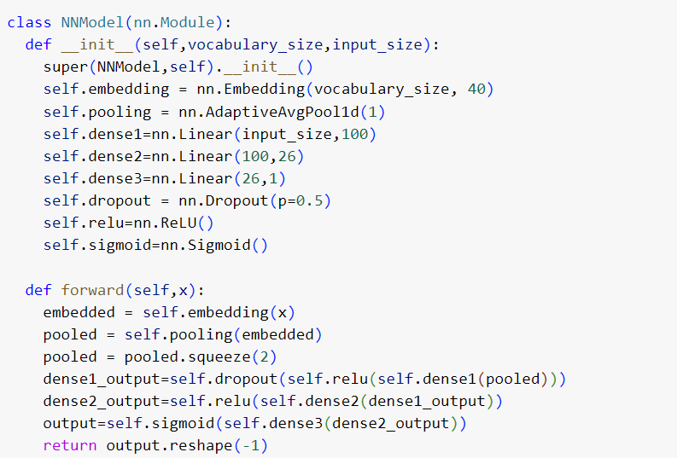

  - Batch_size=32 tokenize_max_len=100 validation_accuracy: 0.89 test_accuracy: 0.88, lr=0.0005,dropout=0.5,embedding_dim=40
  - Bathc_size=32 tokenize_max_len=500 validation_accuracy:0.93 test_accuracy:0.93, lr=0.0005t, dropout=0.5,embedding_dim=40
  - Bathc_size=32 tokenize_max_len=2000 validation_accuracy:0.93 test_accuracy:0.93, lr=0.0005, dropout=0.5, ,embedding_dim=40
  - Bathc_size=32 tokenize_max_len=500 validation_accuracy:0.923 test_accuracy:0.925, lr=0.0005, dropout=0,embedding_dim=40
  - Bathc_size=128 tokenize_max_len=500 validation_accuracy:0.91 test_accuracy:0.91, lr=0.001, dropout=0.5,embedding_dim=40
  - Bathc_size=32 tokenize_max_len=2000 validation_accuracy:0.941 test_accuracy:0.937, lr=0.0005, dropout=0.7,embedding_dim=40
  - Bathc_size=32 tokenize_max_len=2000 validation_accuracy:0.948 test_accuracy:0.951, lr=0.0005, dropout=0.7,embedding_dim=100

- RNN
  - Batch_size=32 tokenize_max_len=500 lr=0.0001 encoding_futures:250 test_accuracy: 0.89 validation:0.90
  - Batch_size=32 tokenize_max_len=500 lr=0.0001 encoding_futures:250 test_accuracy: 0.89 validation:0.90,dropout=0.2
- LSTM
  - Batch_size=128 tokenize_max_len-500 lr=0.0005 encoding_feature=20 hidden_size=20 dropout1=0 dropout2=0 test_accuracy:0.92 validation_accuracy:0.92
  - Batch_size=128 tokenize_max_len-500 lr=0.0005 encoding_feature=20 hidden_size=20 dropout1=0 dropout2=0 test_accuracy:0.93 validation_accuracy:0.93
  - Batch_size=128 tokenize_max_len-500 lr=0.0005 encoding_feature=40 hidden_size=40 dropout1=0.4 dropout2=0.3 test_accuracy:0.96 validation_accuracy:0.96
  - Batch_size=128 tokenize_max_len-500 lr=0.0005 encoding_feature=80 hidden_size=40 dropout1=0.4 dropout2=0.3 test_accuracy:0.95 validation_accuracy:0.96
  - Batch_size=128 tokenize_max_len-500 lr=0.0005 encoding_feature=80 hidden_size=40 dropout1=0.5 dropout2=0.4 test_accuracy:0.95 validation_accuracy:0.95
  - Batch_size=128 tokenize_max_len-1000 lr=0.0005 encoding_feature=80 hidden_size=40 dropout1=0.4 dropout2=0.3 test_accuracy:0.94 validation_accuracy:0.95
  - Batch_size=128 tokenize_max_len-250 lr=0.0005 encoding_feature=80 hidden_size=40 dropout1=0.4 dropout2=0.3 test_accuracy:0.94 validation_accuracy:0.95
  - Batch_size=256 tokenize_max_len-250 lr=0.0005 encoding_feature=80 hidden_size=40 dropout1=0.4 dropout2=0.3 test_accuracy:0.94 validation_accuracy:0.95
  - Batch_size=64 tokenize_max_len-250 lr=0.0005 encoding_feature=80 hidden_size=40 dropout1=0.4 dropout2=0.3 test_accuracy:0.93 validation_accuracy:0.95

Rezultate saptamana 2:

Model | Validation | Test
SVC kernel-linear | 0.97 | 0.97
SVC kernel-rbf | 0.97 | 0.97
Random Forest | 0.94 | 0.95
Neural Networks | 0.94 | 0.95
Recurrent Neural Networks | 0.89 | 0.90
LSTM | 0.96 | 0.96

Observatii: Am incercat antrenarea fiecarui model cu hiper-parametri diferiti. In tabel sunt afisate cele mai bune rezultate obtinute de mine pe parcursul antrenarii.

Rezultate saptaman 3 – AI

SVC-linear:
1.tf-idf,Stemmer, c=0.005, validation=0.86, testate=0.86 , veridica=0.64
2.tf-idf,Lemmatizer c=0.005 validation=0.80 testare=0.81 veridica=0.62
3.stemmer,word2vec- 1; max-length=1000 c=0.005 validation=0.70 testare=0.70 veridica=0.75
SVC-poly:
1.tf-indf,Stemmer c=1 p=2 validation=0.95 testare=0.95 veridica=0.56
2.stemmer,word2vec-1 maxlength=1000 c=1 validation=0.63 testare=0.64 veridica=0.78
RandomForest
1.tf-idf Stemmer max_depth=1500 n_estimators=1500 validation=0.94 testare=0.94 veridica=0.74
2.tf -idf Lemmatizer max_depth=1500 n_estimators=1500 validation=94 testare=94 veridica=0.73
SVC-RBF:
1.stemmer,word2vec-1 max-length=1000 c=0.005 validation=0.63 testare=0.63 veridica=0.99
2.stemmer,wrod2vec-1 max-lenght=1000 c=0.5 validartion=0.7 testare=0.71 veridica=0.83
3.stemmer,wrod2vec-1 max-lenght=1000 c=5 validartion=0.7 testare=0.7 veridica=0.73
4.stemmer,wrod2vec-1 max-lenght=1000 c=10 validartion=0.7 testare=0.7 veridica=0.7
NN
1.tokenize, max_len=500 validation=0.75 testare=0.75 veridica=0.77 lr=0.0005 epochs=20, embedding-dropout=0.8 dropout=0.5 batch_size=512, embedding-dim=10
2. tokenize, max_len=500 validation=0.79 testare=0.81 veridica=0.67 lr=0.0005 epochs=20, embedding-dropout=0.8 dropout=0.5 batch_size=512, embedding-dim=10
3. tokenize,max_len=500 validation=0.81 testare=0.81 veridica=0.80 lr=0.0005 epochs=20, embedding_dropout=0.4 dropout=0.3 batch_size=1024 embedding_dim=40
4. tokenize,max_len=500 validation=0.82 testare=0.82 veridica=0.80 lr=0.0005 epochs=20, embedding_dropout=0.4 dropout=0.3 batch_size=1024 embedding_dim=40
LSTM
1.tokenize,max_len=500 validation=0.82 testare=0.83 veridica=0.6 lr=0.0005 epochs=20, embedding_dim=40,hidden_dim=100
2. tokenize,max_len=500 validation=0.82 testare=0.81 veridica=0.47 lr=0.0005 epochs=20, embedding_dim=40,hidden_dim=100

RNN
1.tokenize,max_len validation=0.70 testare=0.69 veridica=0.49 lr=0.0005 epochs=60, embedding_dim=40, hidden_size=100

DistilBert:
1.raw_data, tokenizerdistilbert,dropout=0.2, attention_dropout=0.2, validation=0.80 testare=0.79 veridica=0.49, lr=1*10^-7, epoch=2
2.stemmer_stopwords_data,tokenizerdistilbert,dropout=0.2, attention_dropout=0.2 validation=0.73, testare=0.72, veridica=0.71

Transformer:
1.stemmer_stopwords_data,embedding_dim=40,number_layer=3,number_head=4,ff_hidden_size=32,dropout=0.3, validation=0.80 testare=0.80 veridica=0.81,batch_size=100
2.stemmer_stopwords_data,embedding_dim=40,number_layer=3,number_head=4,ff_hidden_size=32,dropout=0.3, validation=0.80 testare=0.80 veridica=0.81,batch_size=150

Se observa faptul ca exista un trade off intre veridica si setul de date de pe kaggle; cu cat modelul are un scor mai mic pe kaggle cu atat are un scor mai mare pe veridica si invers; am incercat sa testez rezultatele unui model nn neantrenat iar acuratetea pe veridica este 0.52( nu face nimic)

Am incercat si alte modele in afara de DistilBert-> problema este ca dimensiunea lor este prea mare si nu mi se permite sa fac tuningul pe gpu-uri; imposibil sa faci training pe cpu-uri.
In general modele preantrenarte sunt complexe deci este foarte usor sa se faca overfitting. Pentru datele noastre, modele pre-antrenate realizeaza overfitting in ciuda adaugarii unor straturi de dropout. Scoaterea punctuatiei si aplicarea operatiei de stemmer asupra cuvintelor face posibila o generalizare mai buna insa rezultatele nu sunt la fel de bune ca in cazul retelelor neurale care reusesc sa generalizeze cu succes datele

Rezultate saptaman 5
SVM
1.Linear, word2vec, stemmer, c=0.01, veridica=0.73 validation=0.69 testare=0.69 antrenare=0.75
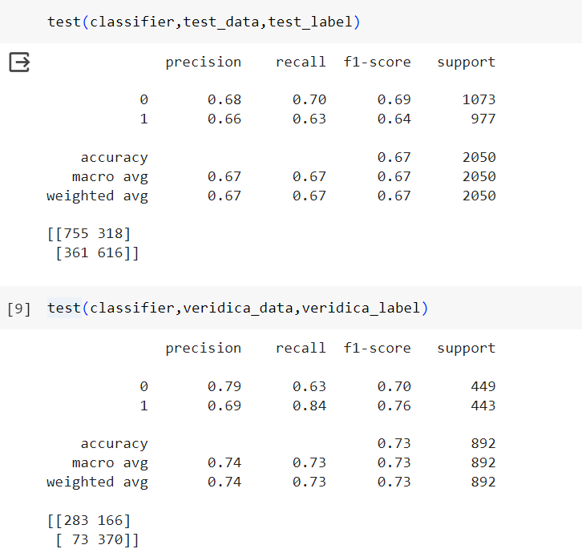
2.RBF,word2vec c=10 veridica=0.70 testate=0.70 antrenare=0.75
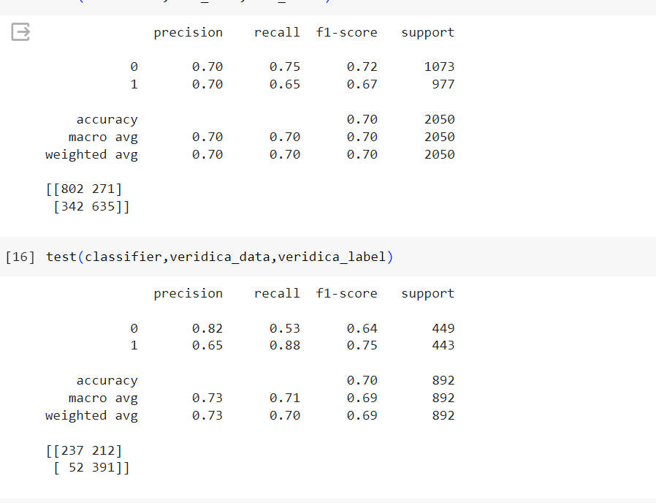

Random Forest
1.tfidf , max_depth=500 n_estimators=500 veridca=0.73 testare=0.93 validare=0.94 antrenare=0.97
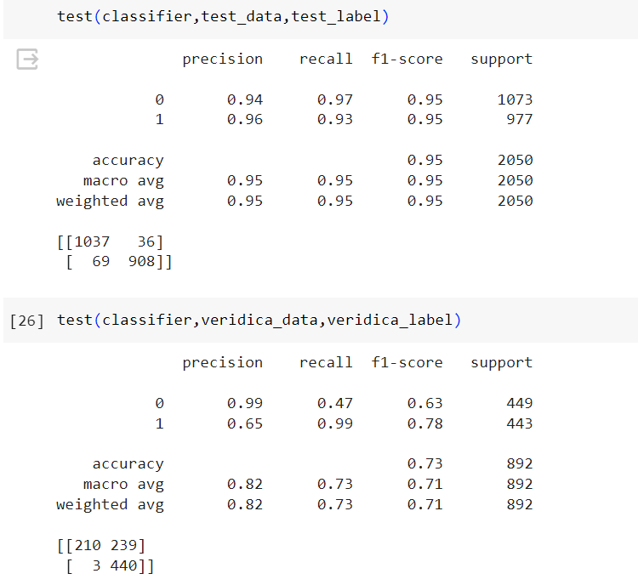

2.tfidf, max_depth=20 n_estimators=500 veridica=0.78 validare=0.92 testare=0.91 antrenare=0.98
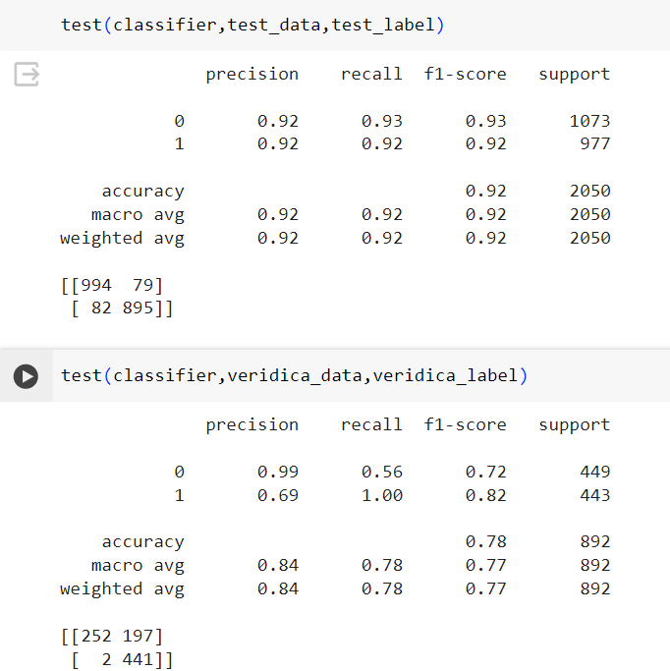

3.tfidf max_depth=10 n_estimators=500 veridica=0.89 validare=0.87 testare=0.87 antrenare=0.90
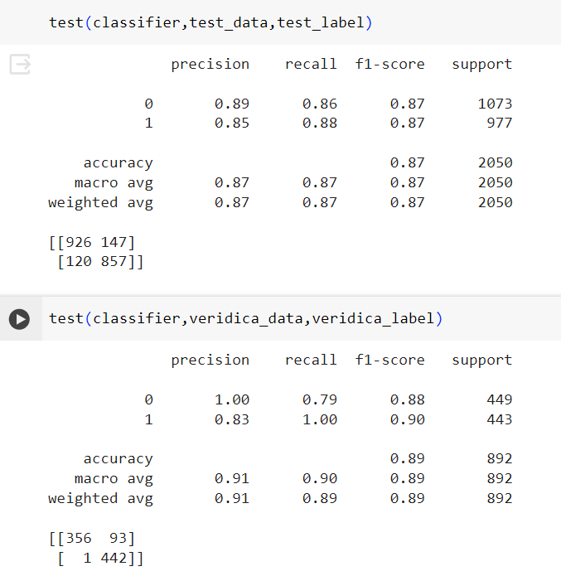

Observatie: probabilitatea ca o stire sa apartina unei clase in cazul random forest este foarte mica pentru random forestul cu 10 -> pentru setul de train,validation si test valoarea maxima nu depaseste 0.8; pentru veridica nu depareste 0.7; pentru random forest cu 20 probabilitatea depaseste si 0.9 pe anumite sampleuri pe train,test,validation, iar pe veridica depaseste 0.75

Pydantic2- definesc structuri date raspunsuri
FastApi
Cum functioneaza un tool de detectie de ai

